- \Operation\Discharging conveyor\Discharging conveyor
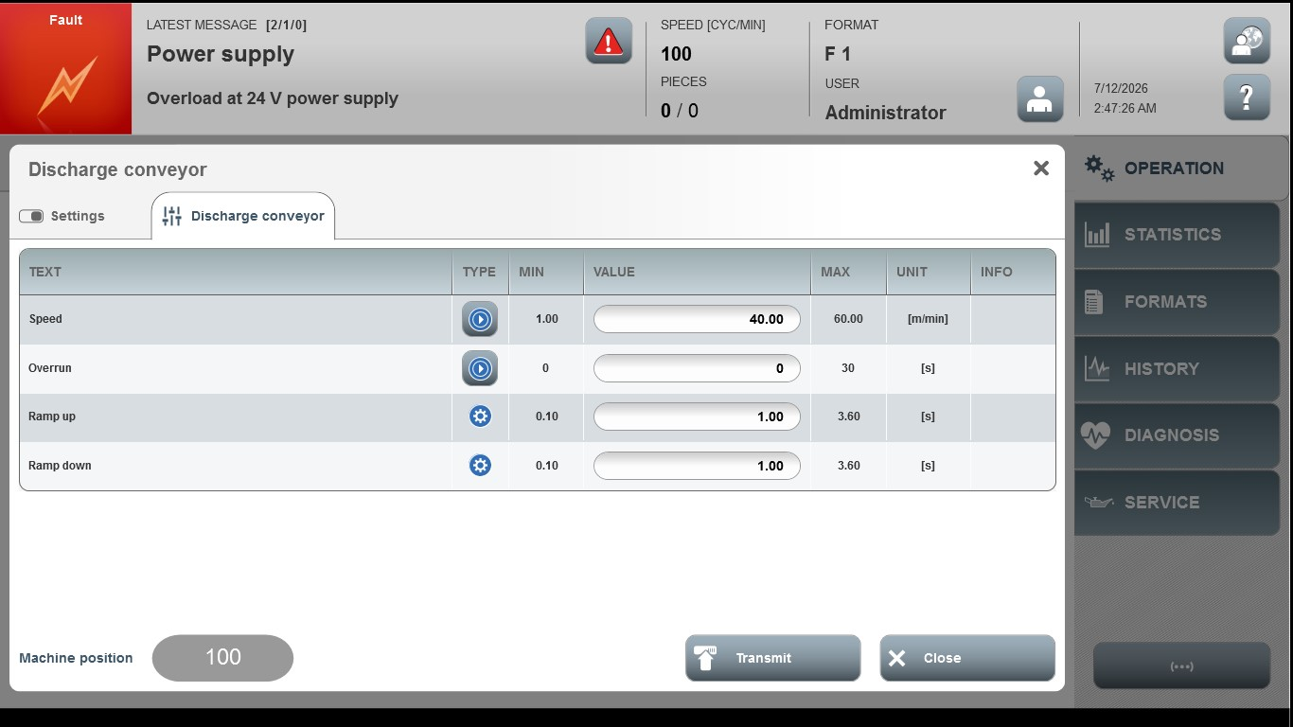

Acceptance criterion | Limits | Pass / Fail: Dev-No. | Date | Initials
Screen matches screenshot | N / A
Speed | 1.00…60.00
Overrun | 0…30
Ramp up | 0.10…3.6
Ramp down | 0.10…3.6

